**Report**

**What is a tornado?**

A tornado is a violently rotating column of air, in contact with the ground, either pendant from a [cumuliform cloud](https://en.wikipedia.org/wiki/Cumuliform_cloud) or underneath a cumuliform cloud, and often (but not always) visible as a funnel cloud.

Sources: <https://en.wikipedia.org/wiki/Tornado>

**How do they form?**

1. Tornadoes form when warm, humid air collides with cold, dry air.
2. The denser cold air is pushed over the warm air, usually producing thunderstorms.
3. The warm air rises through the colder air, causing an updraft.
4. The updraft will begin to rotate if winds vary sharply in speed or direction

Sources: <https://www.nationalgeographic.com/environment/article/tornadoes>

We are studying the factors that can lead to a tornado. Therefore, it is important to understand how they are formed because it gives us insight on what characteristics of the weather to explore.

Through our features and models we want to ask:

* “ What characteristics of the weather play a part in the formation of a tornado ?”
* “ How do these characteristics behave? ”
* “ How significant are these characteristics as causes to forming a tornado relative to each other? ”
* “ Can the relationships between these characteristics be identified as indicators of a tornado? ”

**Features:**

We have chosen to study these features during the 21 day period before the tornado because weather conditions before that seem to be much less significant and we believe negligible.

Weather Metrics:

1. Temperature:

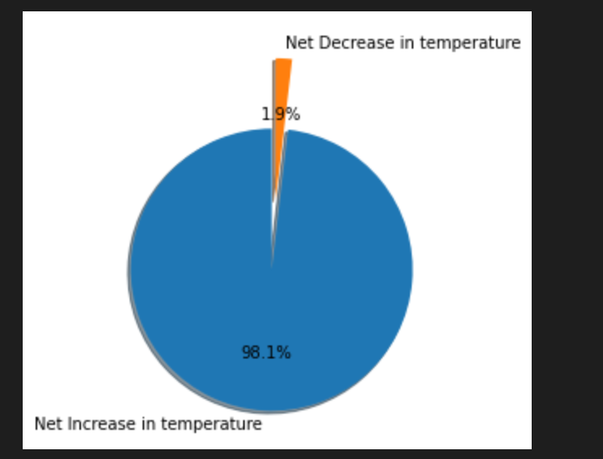

We explored that there is a temperature increase before tornadoes 98% of the time, this led us to further investigate temperature.

1. Windspeed
2. Relative humidity
3. Surface pressure:
4. Total precipitation: We have explored massive rainfall in the immediate period and thus have chosen this as a feature

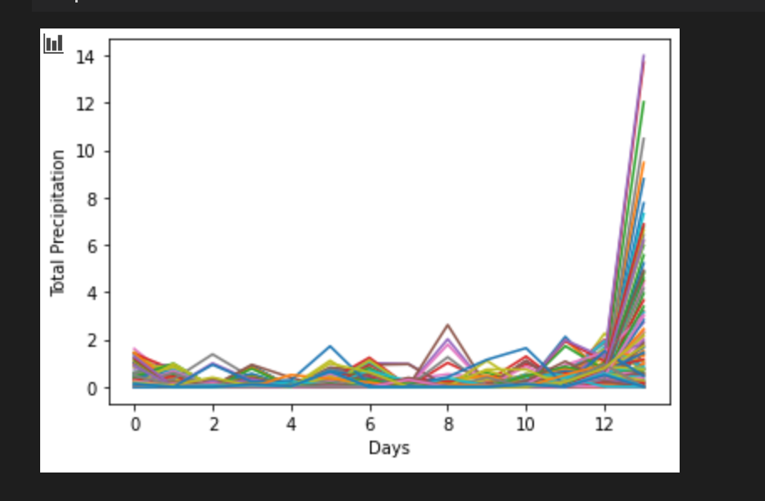

Slopes:

1. Temperature: We explore the rolling slope of the temperature to see if there is a pattern in how the temperature actually increases before.
2. Relative humidity:
3. Surface pressure:
4. Total precipitation

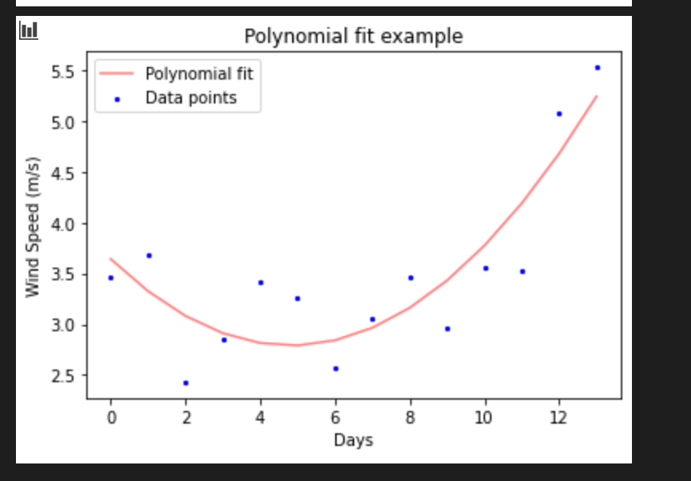

We have explored that there is a spike in precipitation before.

Ratios:

** We would like to generate ratios between these features in the next stage **

1. Delta(Humidity)/Delta(Temperature): collisions between hot humid air and cold dry air seem to increase the likelihood of tornadoes

**Models**

We chose these models because they are the best for binary classification problems and we are trying to classify if a sample is or is not a tornado.

1. Logistic Regression
2. Naive Bayes
3. Decision Trees